DEVELOP WEB APPLICATION USING NODE RED SERVICE

CREATE AN HTTP REQUESTS TO COMMUNICATE WITH

MOBILE APP

|  |  |
| --- | --- |
| TEAM ID | PNT2022TMID17622 |
| PROJECT NAME | Real-Time River water Quality Monitoring and Control System |
| MAXIMUM MARKS | 4 MARKS |

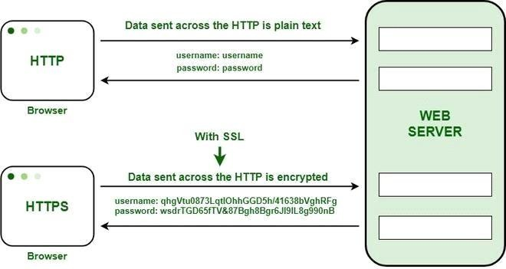

• Private Key: It is used to decode material that has been encrypted with the public key. It is located on the server and is managed by the website's owner. It is personal in nature.

• Public Key: It is a public key that is available to all users that connect with the server. The private key is used to decode data that has been encrypted with the public key.

